**Diamond Analysis Linear Reg Report**

**Data Description**

Data set is about diamonds what are the features that determine the diamond price

Which has five columns and 54,000 rows with no null values

**Features Titles**:

carat, cut, color, clarity, depth, table, price, x, y, z

where x, y ,z are measuring the diamond dimension



**Data Preprocessing:**

No nulls were found , unnamed column was dropped

**Objective:**

predicting the diamond price by training the different models on the dataset

depending of their features carat, cut, color,

clarity, depth, table using different models and chose the best accurate model

Feature with P-values more than 0.05 were dropped



Correlation between feature:

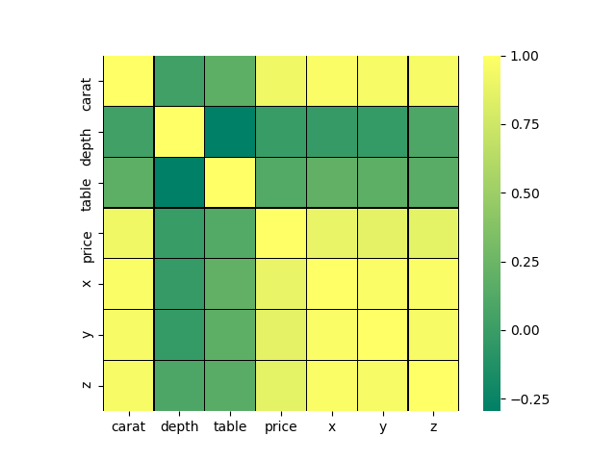

**Models Evaluation And conclusion :**

**Linear:**

R-squared: Between Test And Predict 0.9209268693223643

R-squared: Between Train And Predict 0.9192587702706269

Mean Absolute Error: 0.18551101366375644

Mean Squared Error: 0.07912802142411524

Root Mean Squared Error: 0.2812970341544952

RMSE is 0.28 which is very less and the algorithm did an excellent of prediction

**KNN:**

With best prams of neighbour of 3 scored: 0.941664883093943

**SDGRegresser:**

With best prams of 'alpha': 0.001, 'eta0': 0.01, 'learning rate': 'constant

Scored: 0.9183967446859295

**AdaBoostRegressor with DecisionTreeRegressor:**

With Best Prams: max_depth:3), learning_rate = 0.02, n_estimators = 110

Scored: 0.8772176690021309

**RandomForestRegressor:**

With Best Prams:max_depth': 9, 'n_estimators 180' scored: 0.9523561513872565

**SVR:**

With Best Prams :'kernel': 'poly' scored :0.9698689252989894

Most of the models have same around of score except the decision Tree has less

SVR had highest score

**LGBT Analysis Logistic Reg Report**

**Data Description**

Data is about a survey asked to lesbian, gay, bisexual and transgender (LGBT) people whether they had experienced discrimination, violence, verbal abuse or hate speech on the grounds of their sexual orientation or gender identity. The results reflect the experiences of more than 93,000 individuals who completed the online survey across Europe.

* **Features Titles**:

CountryCode, subset, question_, code, question_label, answer, percentage, notes.

* **Data Preprocessing:**

Percentage column null values filled up with mean

Note column was dropped has too many null values

Answer column was encoded 1-26

**Objective:**

predicting the price of the diamond depending of their features carat, cut, color,

clarity, depth, table using different models and chose the best accurate one

**Models Evaluation & conclusion:**

Logistic Mode:



**Random Forest:**

With best prams: max_depth=19, estimators=150, criterion': entropy

Scored:0.9995465720964399

**DecisionTreeClassifier**

With best prams: learning rate': 0.02, 'estimators': 100

Scored:1

**SGDClassifier:**

With best: prams: ‘alpha': 0.01, 'eta0': 0.001, 'learning rate': 'optimal'

Scored:0.9374171468778725

**Perceptron:**

0.7027255440523981

**SVC:**

With best prams: 'kernel': 'linear'

Scored: 0.9993660568737548

Decision trees model suffer from overfitting, however random forests prevents overfitting by creating trees on random subsets.

Random forests is slow in generating predictions and has high accuracy SVC with linear kernel is more accurate than Random

Forest.

Perceptron has the lowest accuracy among all models